KENNEDY MBUGUA

[KENKIN1672@GMAIL.COM](mailto:KENKIN1672@GMAIL.COM)

TECHCRUSH

CLOUD COMPUTING TRACK

YEAR 2025

CAPSTONE PROJECT

IAM Roles and Secure Access Automation

Project 3: IAM Roles and Secure Access Automation (GROUP 4) FOR GROUP 4 ONLY

Objective:

Automate the setup of secure identity and access controls using Azure CLI and Bash scripting.

Tasks:

1. Create a resource group, virtual network, and two subnets (Web and DB).

2. Create Azure AD groups: 'WebAdmins' and 'DBAdmins'.

3. Assign Reader role to DBAdmins for DB subnet resources.

4. Add test users to the AD groups and validate role assignments.

BONUS: Include scripts to revoke access or remove roles for cleanup, also using a CI/CD pipeline to automate the whole process

DELIVERABLES: Script(s) used for deployment and management of IAM roles, screenshot of the entire deployment.

Tasks:

1. Create a resource group, virtual network, and two subnets (Web and DB).

LOCATION="eastus"

RG_NAME="IAMResourceGroup"

VNET_NAME="IAMVNet"

SUBNET_WEB="WebSubnet"

SUBNET_DB="DBSubnet"

SUBNET_PREFIX_WEB="10.0.1.0/24"

SUBNET_PREFIX_DB="10.0.2.0/24"

VNET_PREFIX="10.0.0.0/16"

WEB_ADMINS="WebAdmins"

DB_ADMINS="DBAdmins"

USER1=" kennedy.mbugua@jamesngigioutlook.onmicrosoft.com "

USER2="Mr.temiloluwa@jamesngigioutlook.onmicrosoft.com"

**CREATING A RESOURCE GROUP**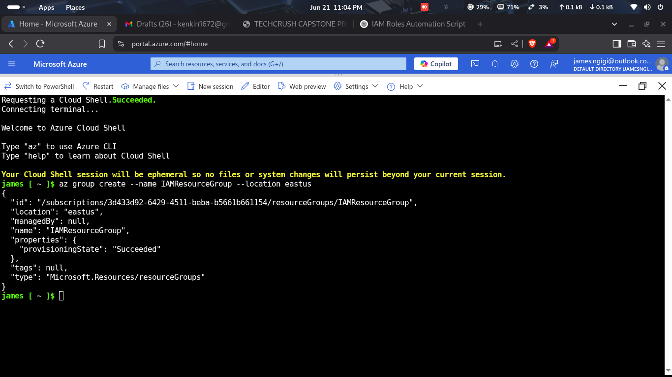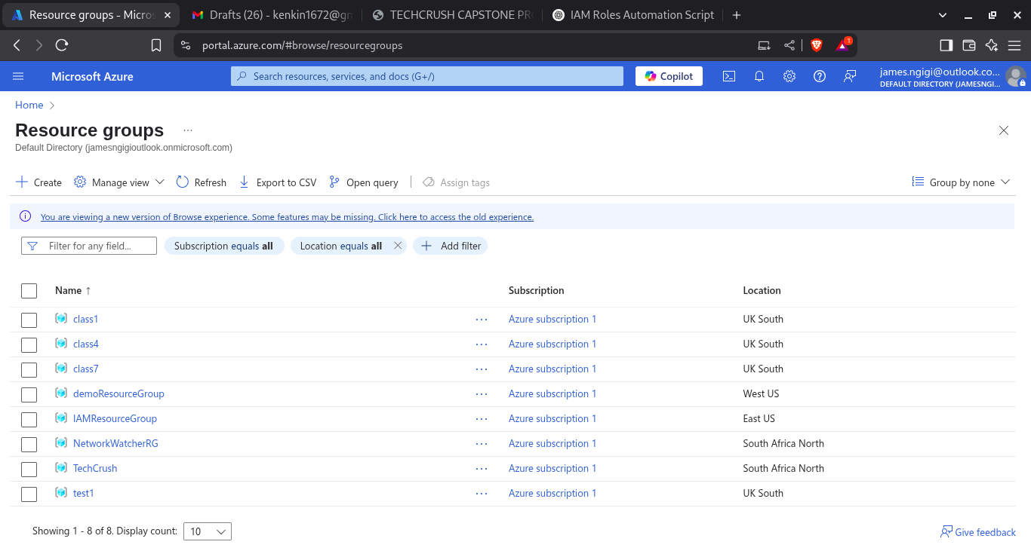

**CREATING A VIRTUAL NETWORK.**

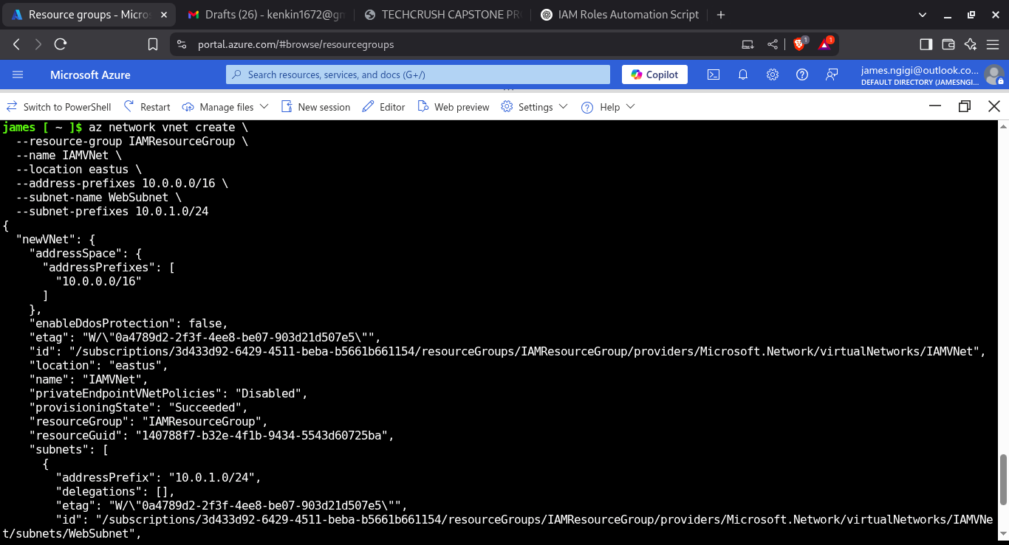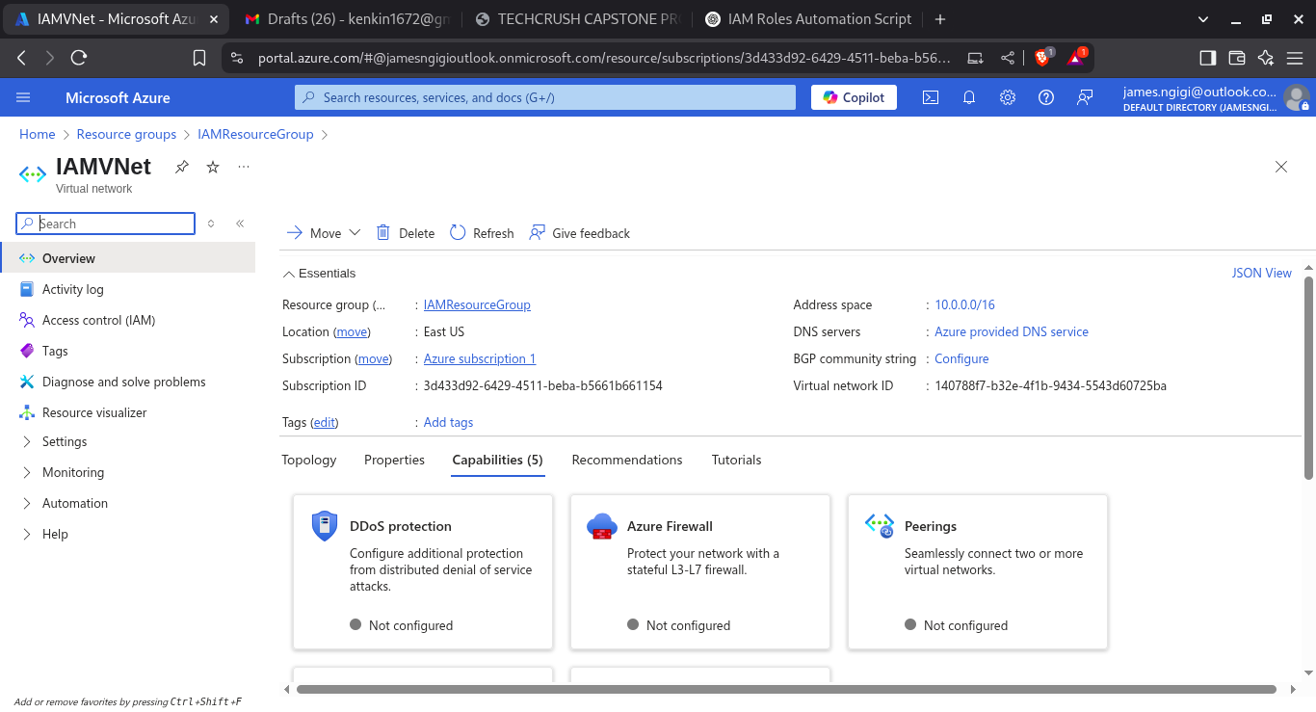

**CREATING TWO SUBNETS**

**DBSubnet**

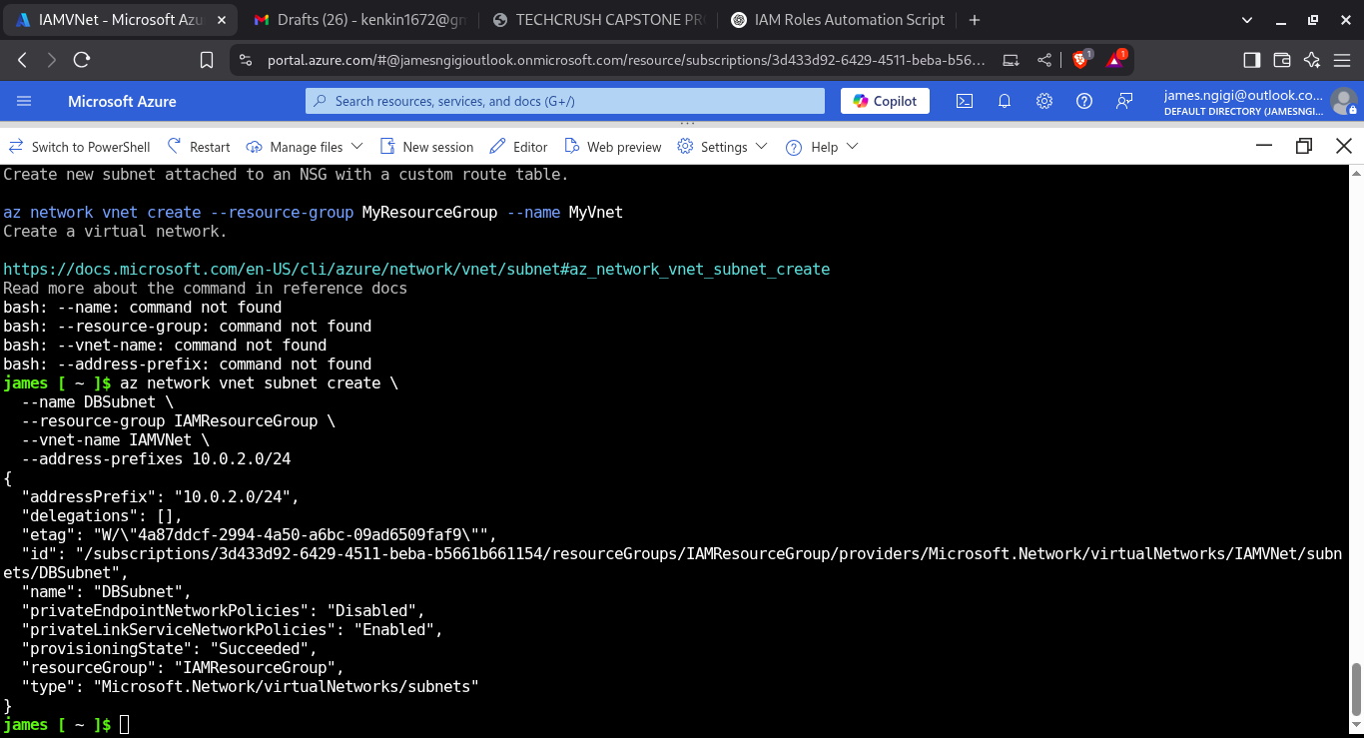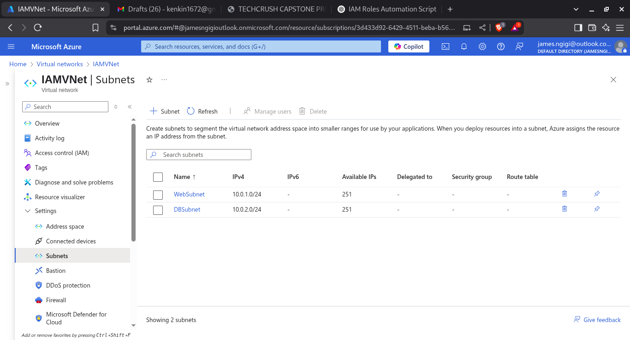

**CREATING TWO SUBNETS**

**WebSubnet**

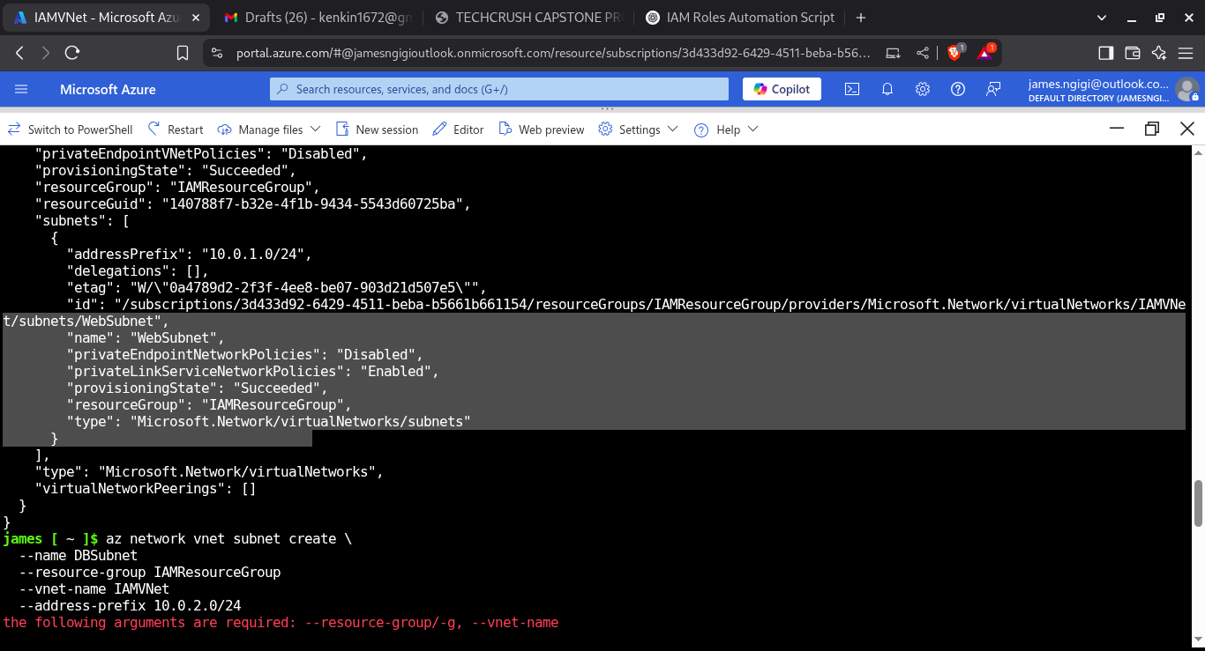

2. Create Azure AD groups: 'WebAdmins' and 'DBAdmins'.

**CREATING WEBADMINS GROUP**

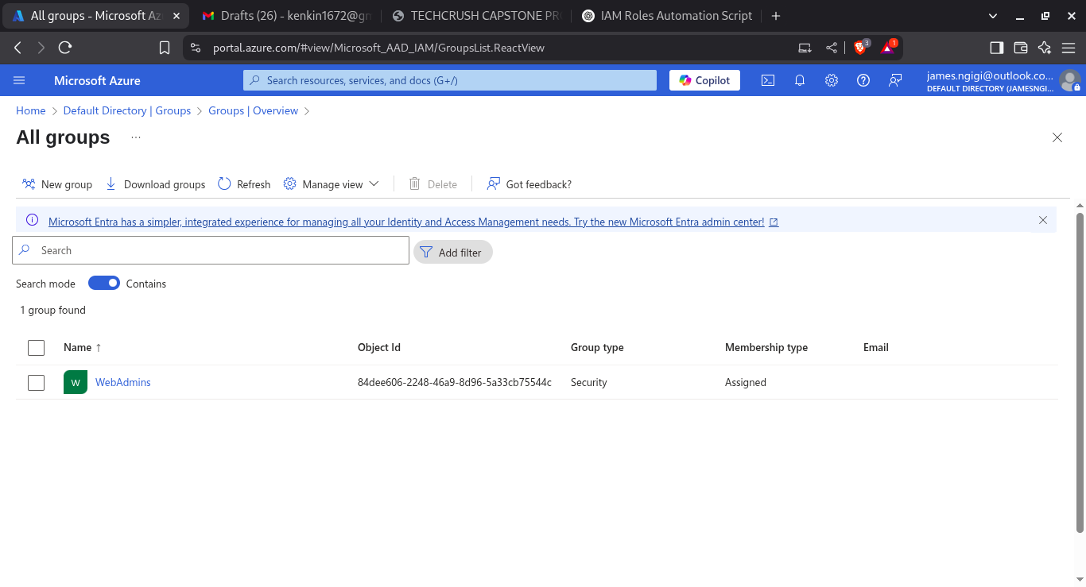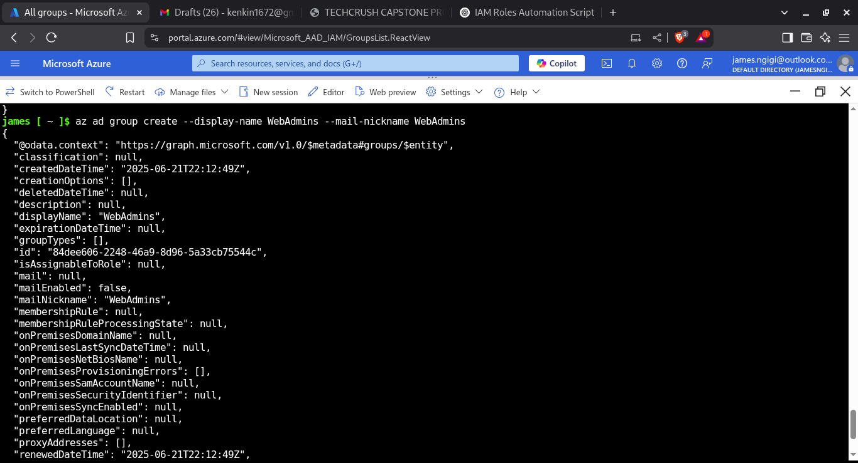

**CREATING DBAdmin GROUP**

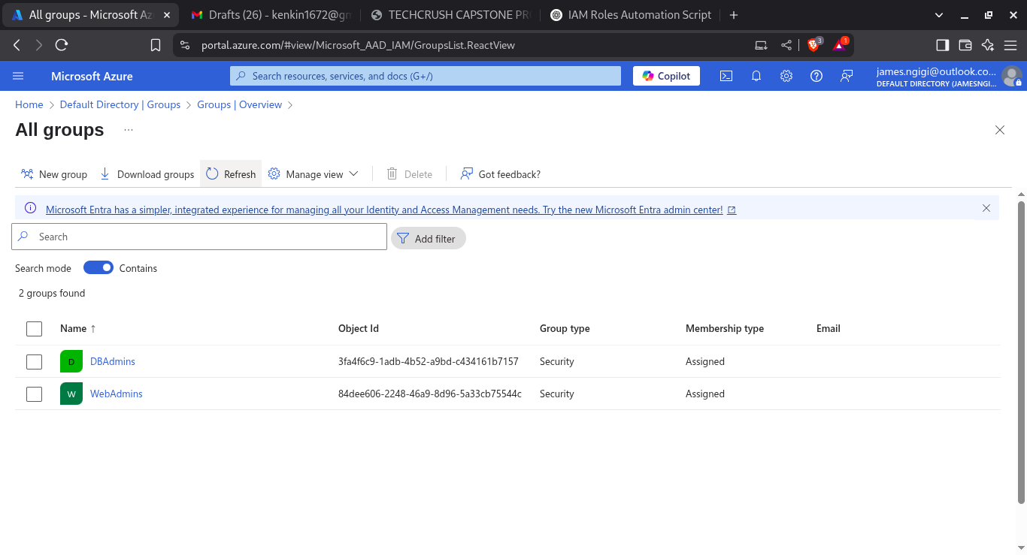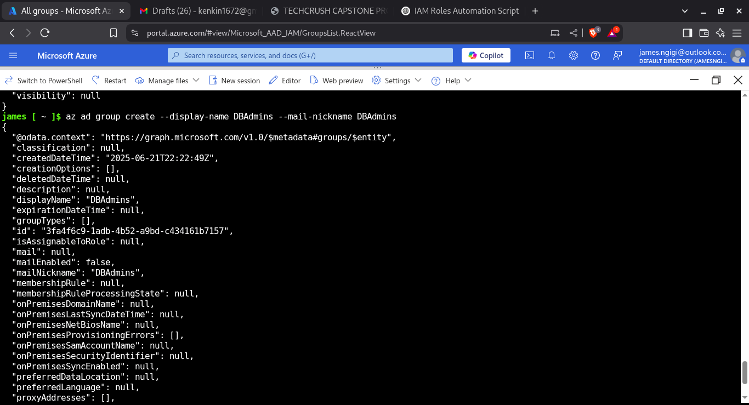

4. Add test users to the AD groups and validate role assignments.

**CREATING USERACCOUNTS**

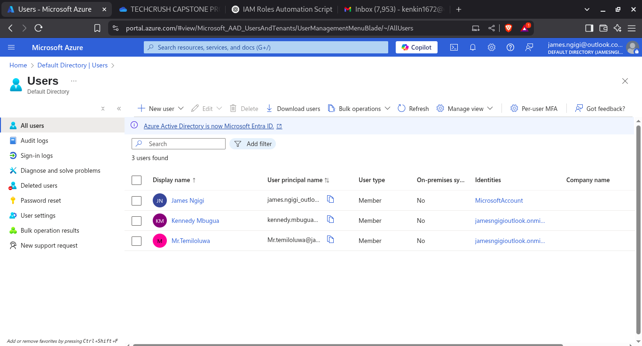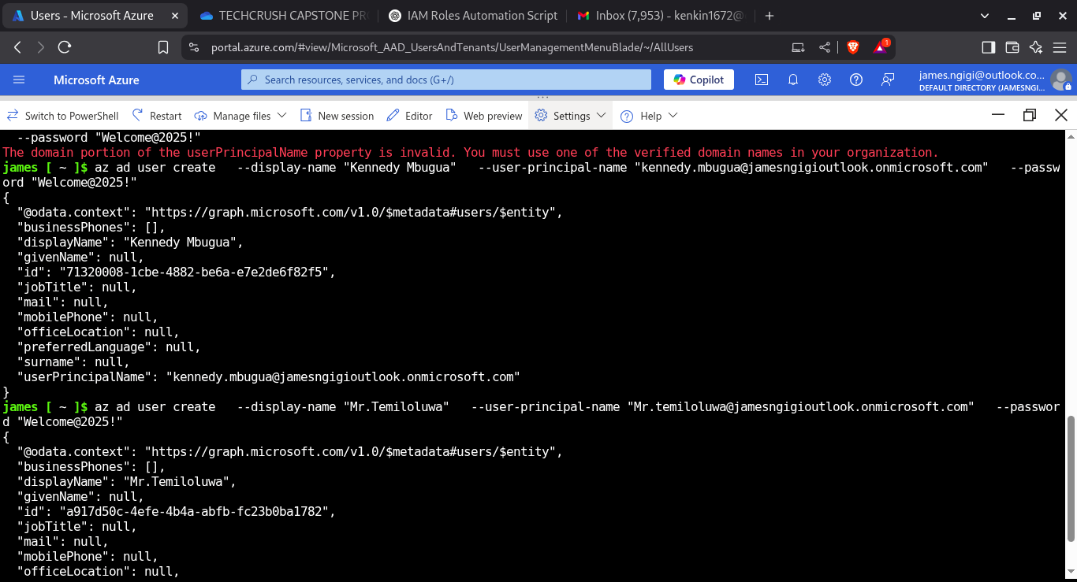

**ADDING USERS TO GROUPS**

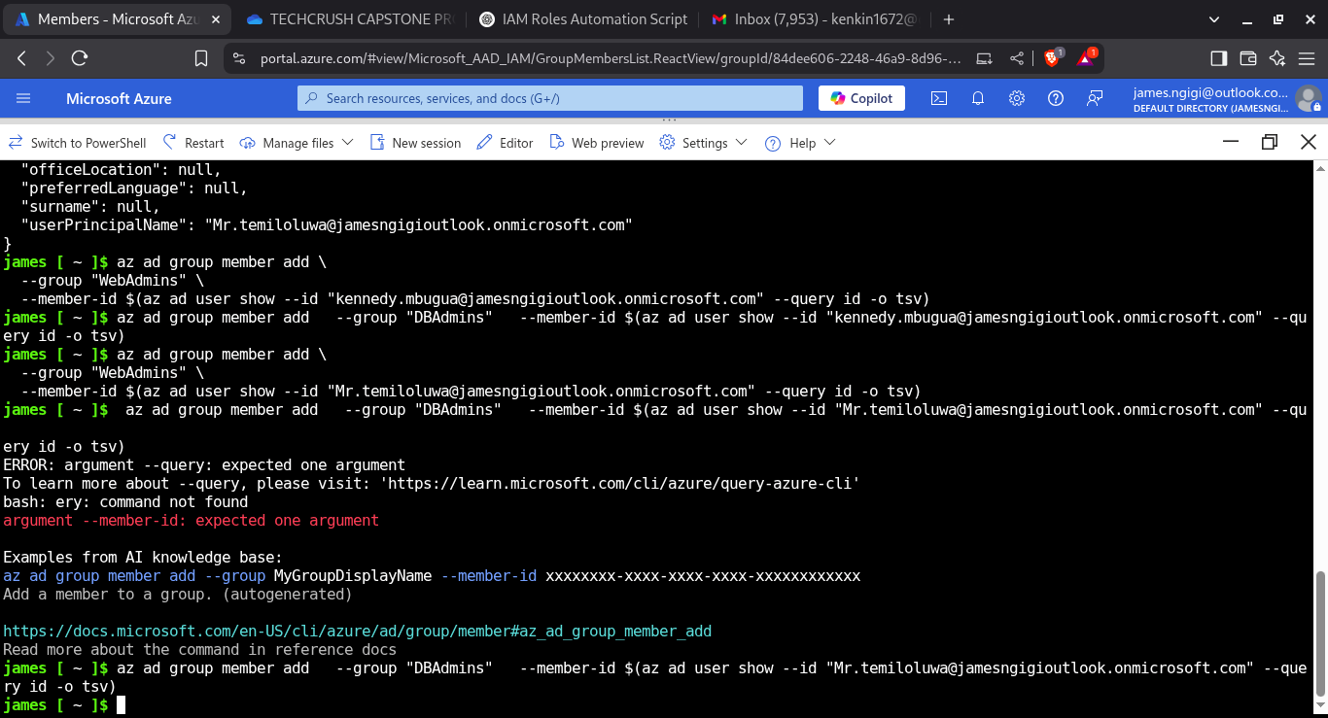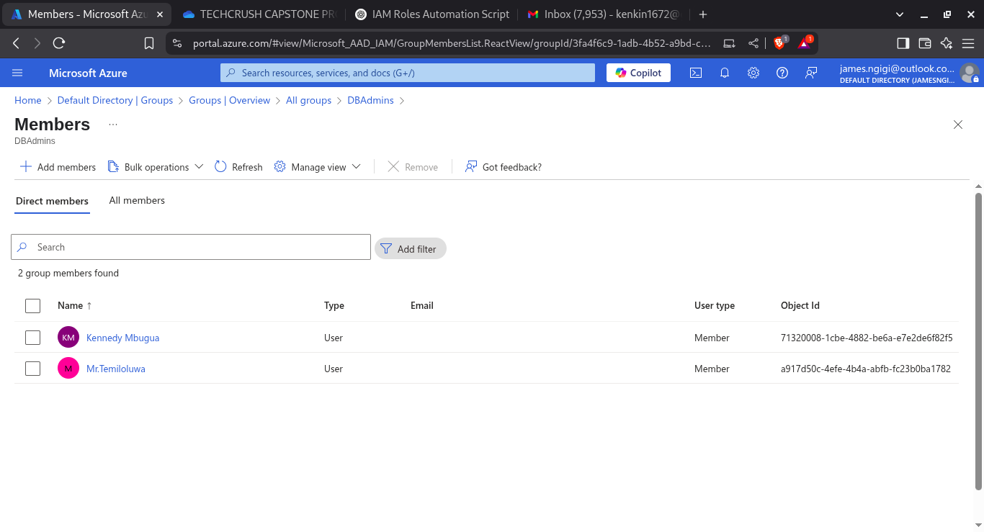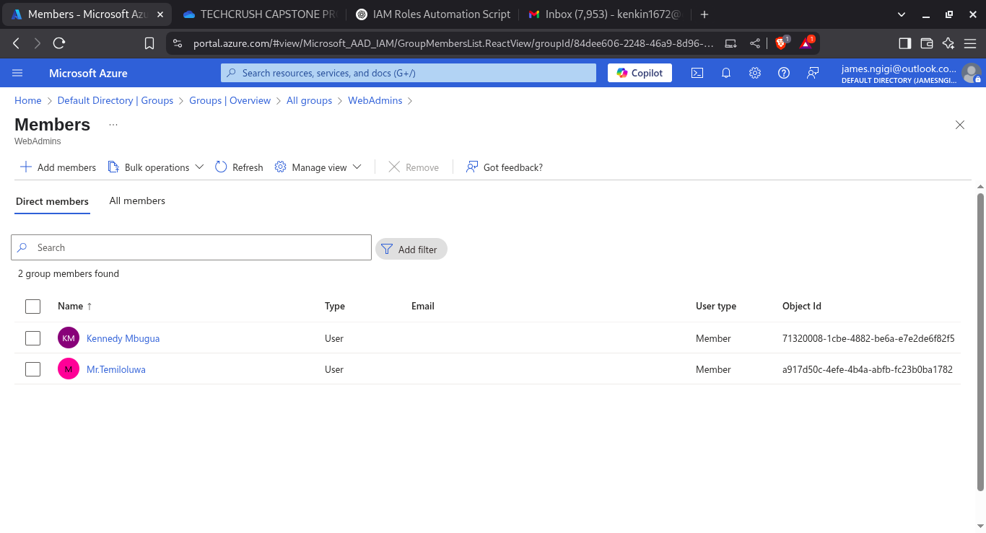

3. Assign Reader role to DBAdmins for DB subnet resources.

**Assigning Reader role to DBAdmins on DB subnet**

Getting the subnet ID for DB subnet and getting the object ID of the DBAdmins group

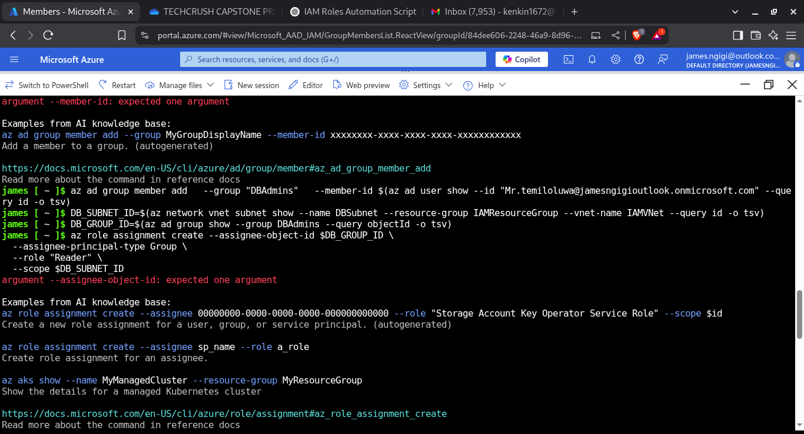

Assigning Reader role to DBAdmins on DB subnet

